Q6. Create a package CIE which has two classes- Student and Internals. The class Personal has members like usn, name, sem. The class internals has an array that stores the internal marks scored in five courses of the current semester of the student. Create another package SEE which has the class External which is a derived class of Student. This class has an array that stores the SEE marks scored in five courses of the current semester of the student. Import the two packages in a file that declares the final marks of n students in all five courses.

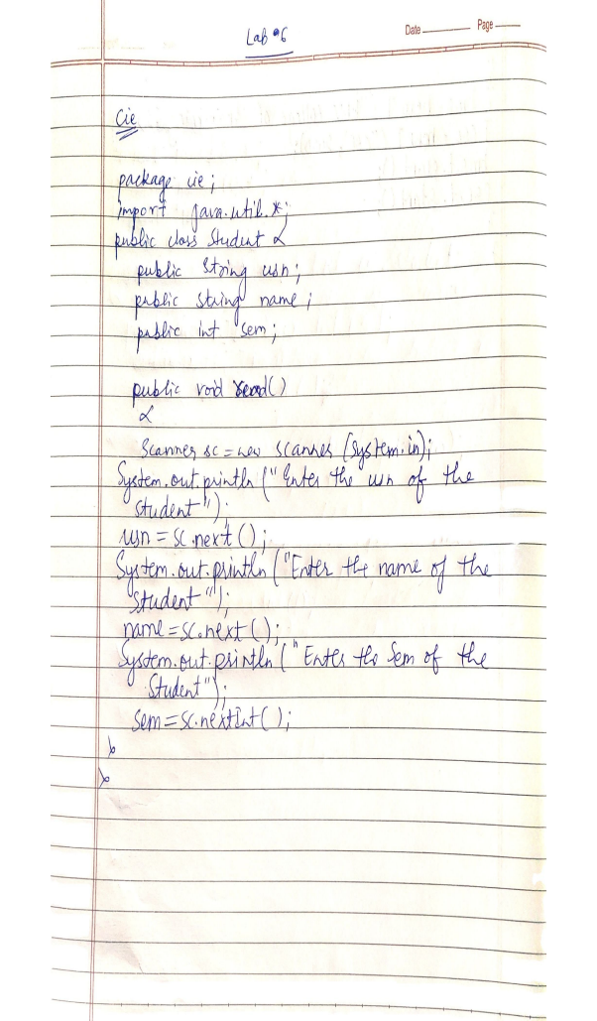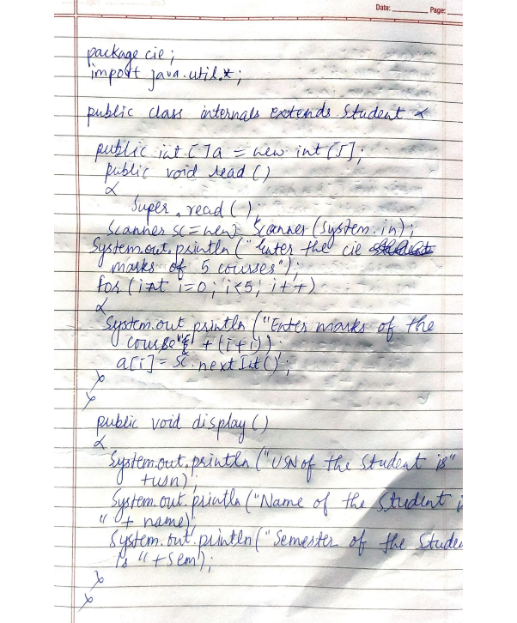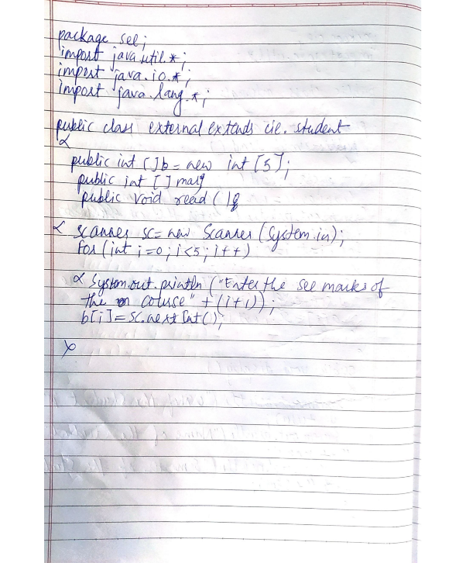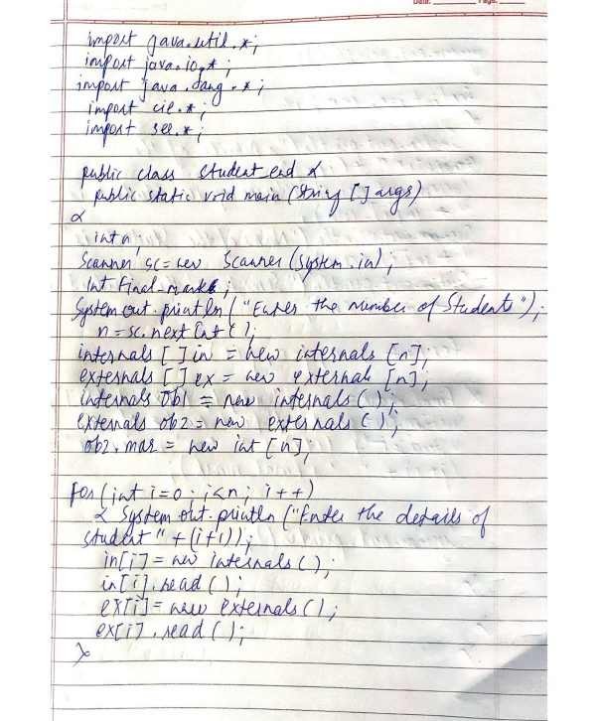

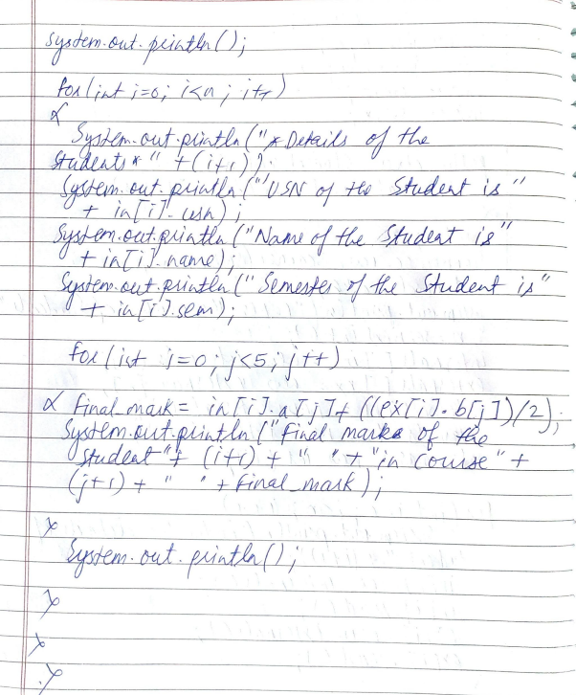

Q7. Write a program to demonstrate generics with multiple object parameters

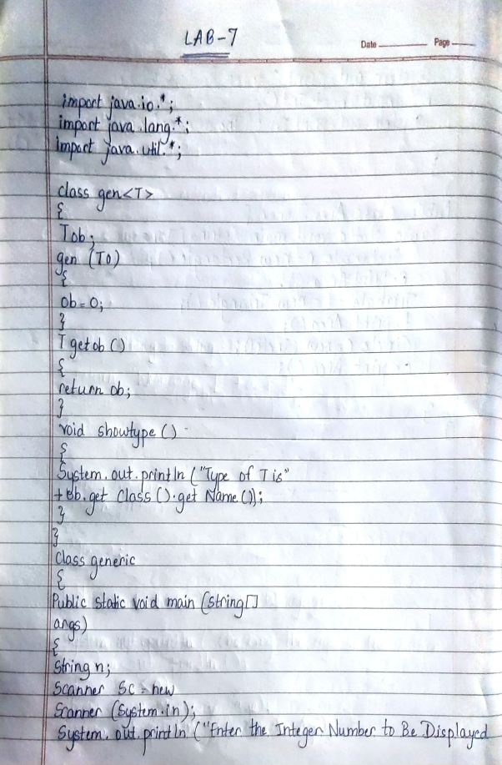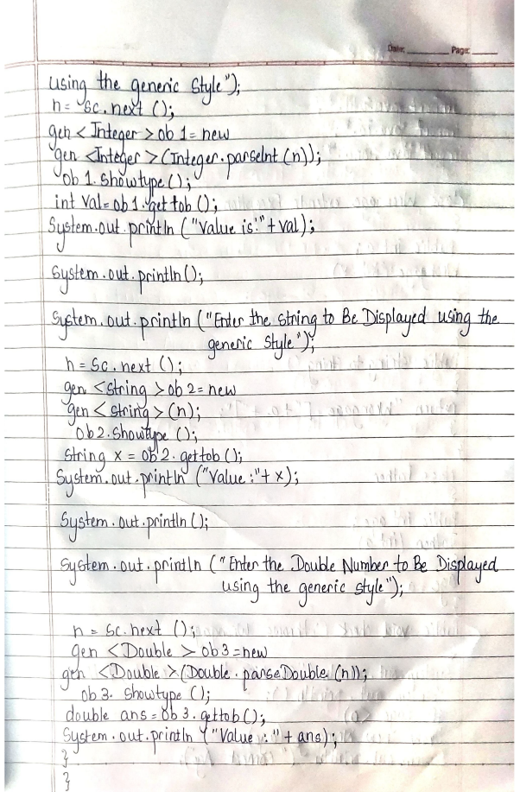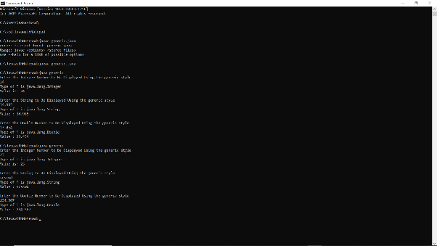

Q8 . Write a program that demonstrates handling of exceptions in inheritance tree. Create a base class called “Father” and derived class called “Son” which extends the base class. In Father class, implement a constructor which takes the age and throws the exception WrongAge( ) when the input age=father’s age.

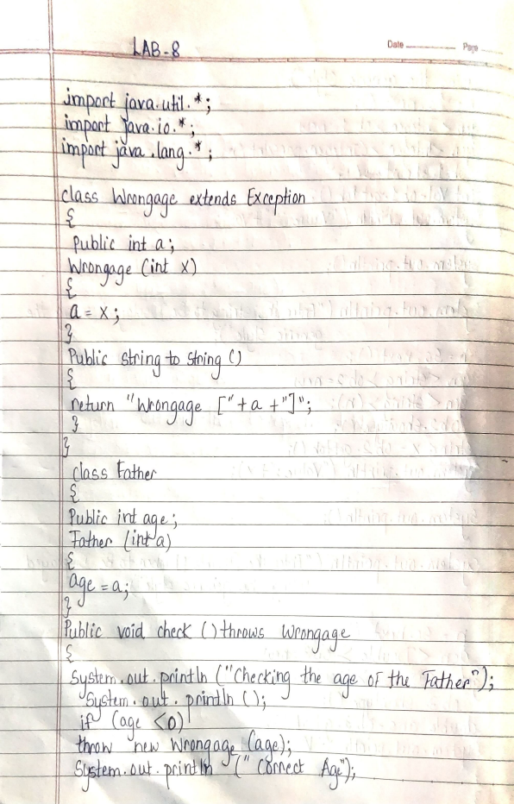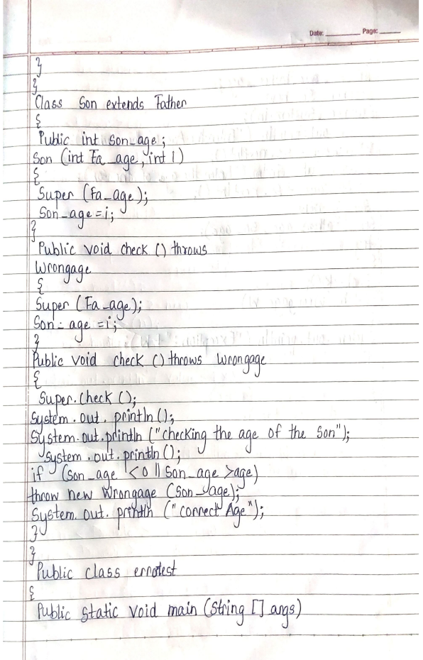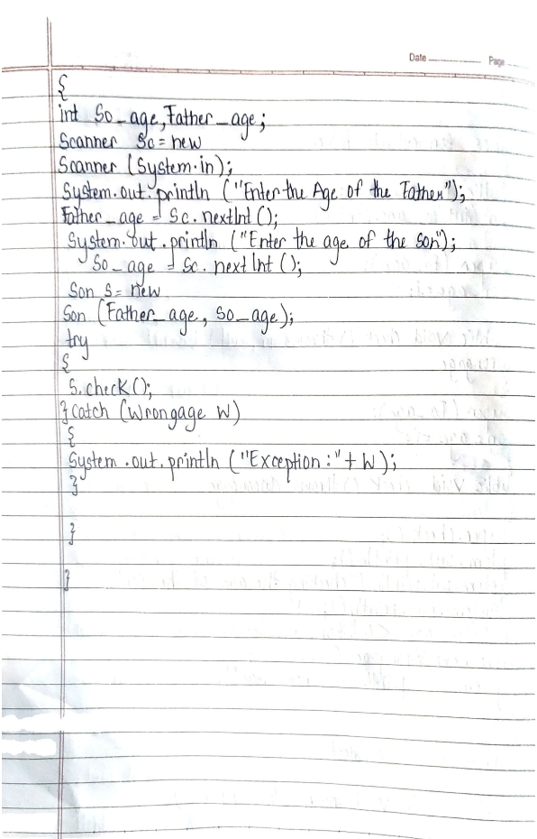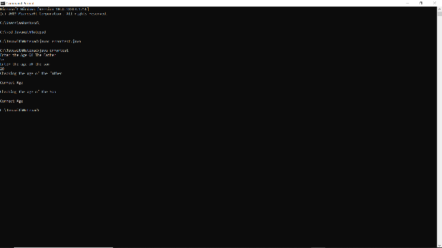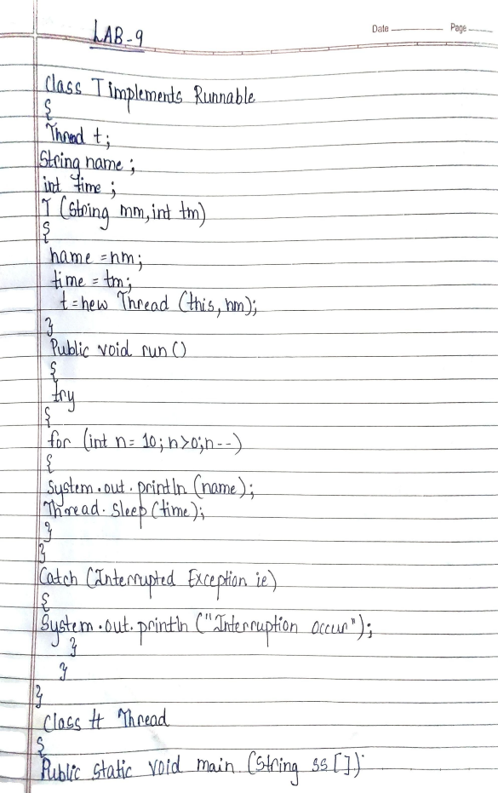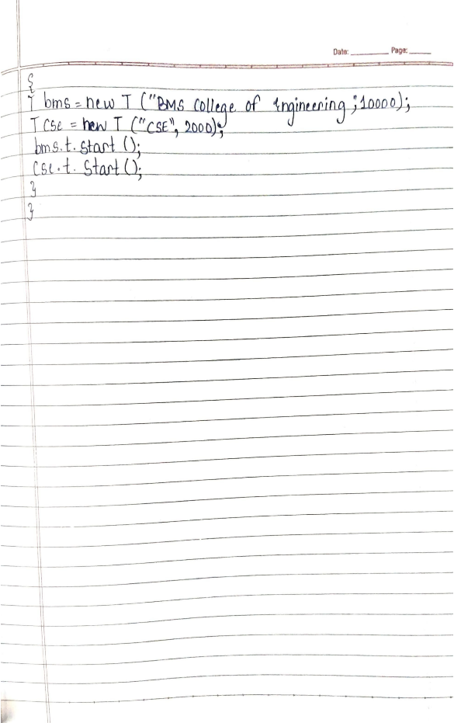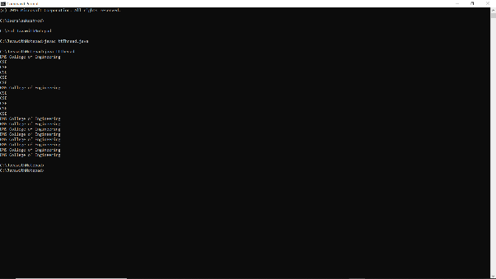

Q10. Write a program that creates a user interface to perform integer divisions. The user enters two numbers in the text fields, Num1 and Num2. The division of Num1 and Num2 is displayed in the Result field when the Divide button is clicked. If Num1 or Num2 were not an integer, the program would throw a NumberFormatException. If Num2 were Zero, the program would throw an Arithmetic Exception Display the exception in a message dialog box.

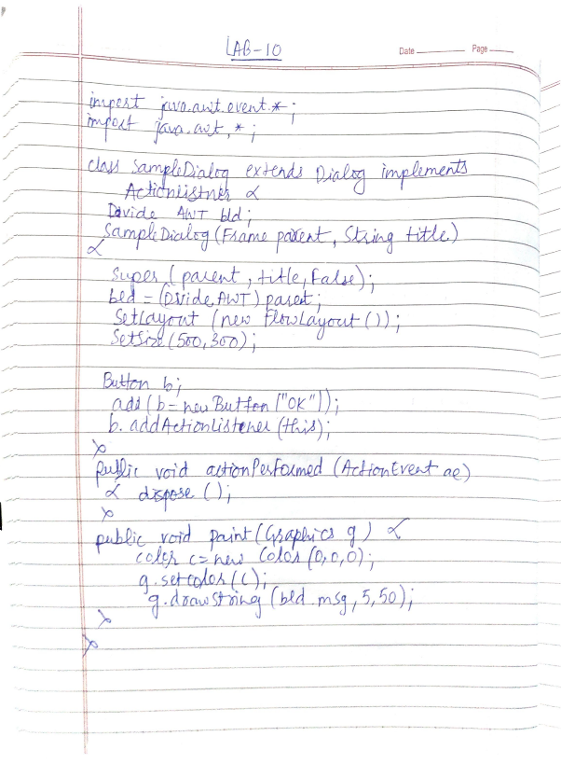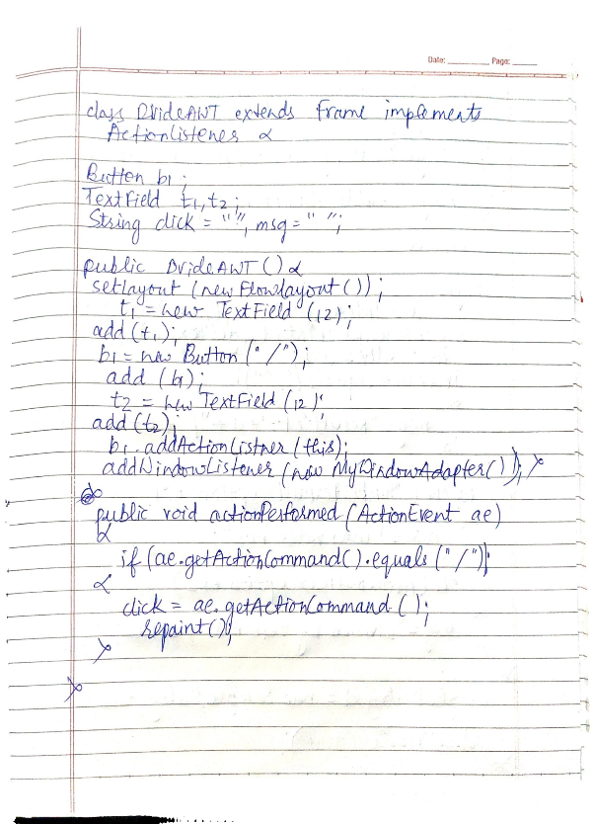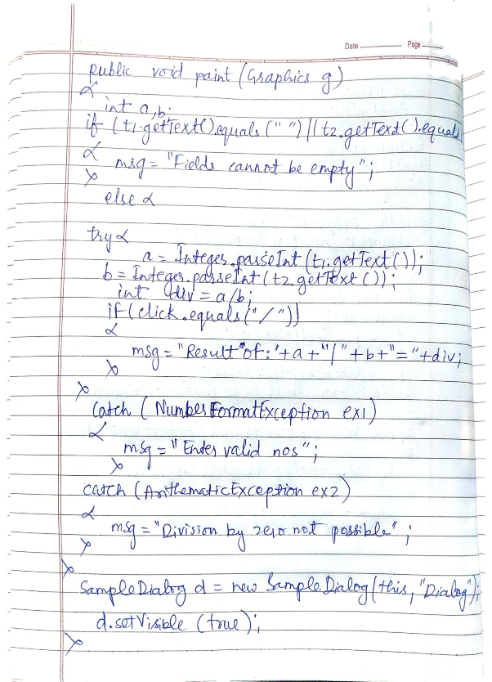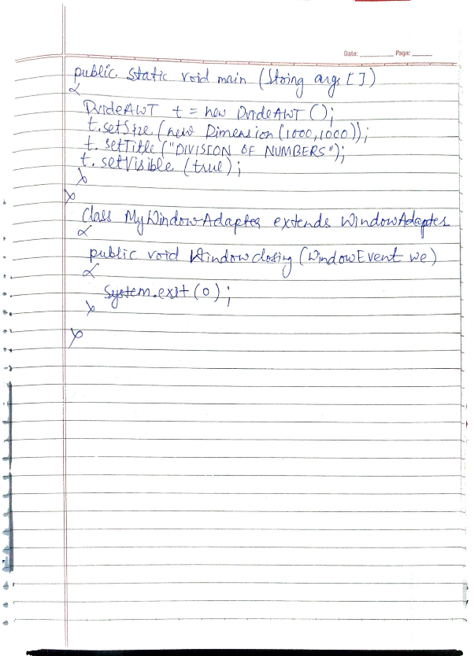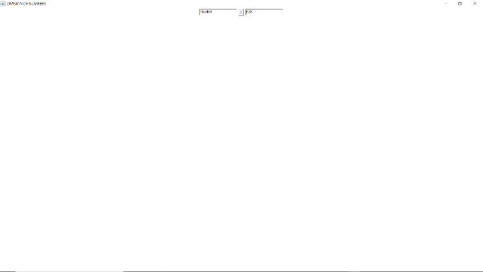

__________________________________ XXXXXXXXXXXXXX________________________________